PS3-Lab 8
Areesha Raheel
55039

Rabin–Karp
Lab Tasks
Q1. Apply the Rabin-Karp algorithm to find the pattern "CA" in the text "ABCAABC".
Show the hash value of the pattern and the hash of each window step by step.
- Text $T=$"ABCAABC"
- Pattern $P=$"CA"
- Pattern length $m=2$
Using simple ASCII values:
Character | ASCII
A | 65
B | 66
C | 67
Take:
- Base $d=256$
- Prime modulus $q=101$

Step 1: Compute Pattern Hash
Pattern = "CA"
$$p=(256×67+65) mod 101$$
First character:
$$p=(0×256+67) mod 101=67$$
Second character:
$$p=(256×67+65) mod 101 \\ =(17217) mod 101=47$$
Pattern Hash = 47

Step 2: Compute First Window Hash
First window = "AB"
$$t=(256×65+66) mod 101 \\ =41$$
First Window Hash = 41

Sliding Window Process
Window 1: "AB"
Hash = 41
Pattern hash = 47
No match.

Window 2: "BC"
Rolling hash update:
$$t_{i+1}=(d(t_{i}-\text{ord}(T[i])×h)+\text{ord}(T[i+m])) mod q$$
Here:
$$h={256}^{1} mod 101=54$$
New hash becomes:
$$t=100$$
Pattern hash = 47
No match.

Window 3: "CA"
New rolling hash:
$$t=47$$
Pattern hash = 47
Hashes match → verify characters.
"CA" = "CA"
Match found at index 2

Window 4: "AA"
Hash:
$$t=40$$
No match.

Window 5: "AB"
Hash:
$$t=41$$
No match.

Window 6: "BC"
Hash:
$$t=100$$
No match.

Final Answer Q1
Pattern "CA" occurs at:
$$\boxed{\text{Index }2}$$
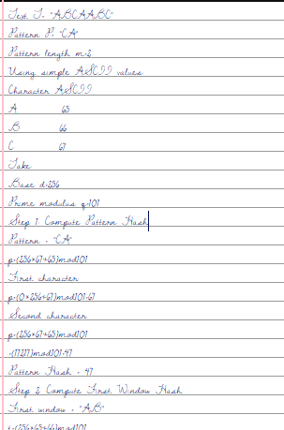
Q2. Text = "AABAACAADAABAABA" Pattern = "AABA". Find all starting indices where the pattern is found using Rabin-Karp.
Windows Checked
Index | Window | Match?
0 | AABA | Yes
1 | ABAA | No
2 | BAAC | No
3 | AACA | No
4 | ACAA | No
5 | CAAD | No
6 | AADA | No
7 | ADAA | No
8 | DAAB | No
9 | AABA | Yes
10 | ABAA | No
11 | BAAB | No
12 | AABA | Yes

Final Answer Q2
Pattern found at indices:
$$\boxed{0, 9, 12}$$
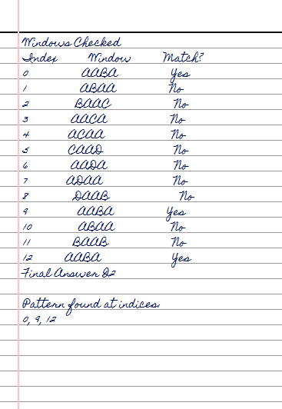
Q3. Text = "abcxabcdabcyabc" Pattern = "abc". List all positions where "abc" occurs. Also mention how many times the rolling hash was used.
Pattern = "abc"
Pattern length:
$$m=3$$
Check all windows of length 3.
Index | Window | Match
0 | abc | Yes
1 | bcx | No
2 | cxa | No
3 | xab | No
4 | abc | Yes
5 | bcd | No
6 | cda | No
7 | dab | No
8 | abc | Yes
9 | bcy | No
10 | cya | No
11 | yab | No
12 | abc | Yes

Final Answer Q3
Pattern "abc" occurs at:
$$\boxed{0, 4, 8, 12}$$
Number of Rolling Hash Uses
Total windows:
$$n-m+1=15-3+1=1$$
First window hash is computed directly.
Remaining windows use rolling hash:
$$13-1=12$$
Rolling hash used:
$$\boxed{12\text{ times}}$$
Q4: Design a log monitoring component for a fintech system that processes high-volume transaction logs. Specify:
- Where Rabin–Karp is applied and why
- Choice of parameters ($d,q$) and their impact
- Handling of collisions and adversarial inputs
- Limitations and proposed improvements or hybrids
- Expected time and space complexity under realistic load

Where Rabin–Karp is Applied and Why
Rabin–Karp can be used in:
- Transaction log scanning
- Fraud pattern detection
- Suspicious keyword identification
- Error signature matching
- Real-time monitoring pipelines
Example suspicious patterns:
- "FAILED_LOGIN"
- "MULTIPLE_WITHDRAWALS"
- "CARD_DECLINED"
- "UNAUTHORIZED_ACCESS"
Why Rabin–Karp?
Because:
- Logs are extremely large
- Multiple patterns must be checked quickly
- Rolling hash makes scanning efficient
- Average complexity is near linear

2. Choice of Parameters $\left(d , q\right)$
Base $d$
Typically:
$$d=256$$
Reason:
- Supports extended ASCII characters
- Efficient for text processing
Prime modulus $q$
Choose a large prime:
Examples:
$$q=101, 1009, 10007$$
Impact
- Reduces collisions
- Keeps hash values bounded
- Improves performance
Larger prime → fewer false matches.

3. Handling Collisions and Adversarial Inputs
Collision Handling
When hashes match:
- Perform direct string comparison
- Confirms true match
- Eliminates false positives

Adversarial Inputs
Attackers may craft logs causing many collisions.
Solutions
- Use larger primes
- Double hashing
- Randomized hash functions
- Hybrid approaches with KMP/Boyer–Moore
4. Limitations and Improvements
Limitations
- Worst-case complexity:
$$O(nm)$$
- Sensitive to collisions
- Less efficient for extremely repetitive text

Improvements
Hybrid Methods
Combine Rabin–Karp with:
- Knuth–Morris–Pratt Algorithm
- Boyer–Moore Algorithm
Benefits
- Better worst-case guarantees
- Faster real-world matching
- Improved resistance to attacks

5. Expected Complexity
Average Case
$$O(n+m)$$
Efficient for large-scale logs.

Worst Case
$$O(nm)$$
Occurs during excessive collisions.

Space Complexity
$$O(1)$$
Only a few variables and hashes are stored.

Short Conclusion
Rabin–Karp is highly suitable for fintech log monitoring because it enables fast real-time pattern searching using rolling hashes. With good parameter selection and collision handling, it performs efficiently on massive transaction logs while maintaining low memory usage.

